IFI Keeps Innovation Flowing With New Arthur Pipkins Sausage and Burger Mixes
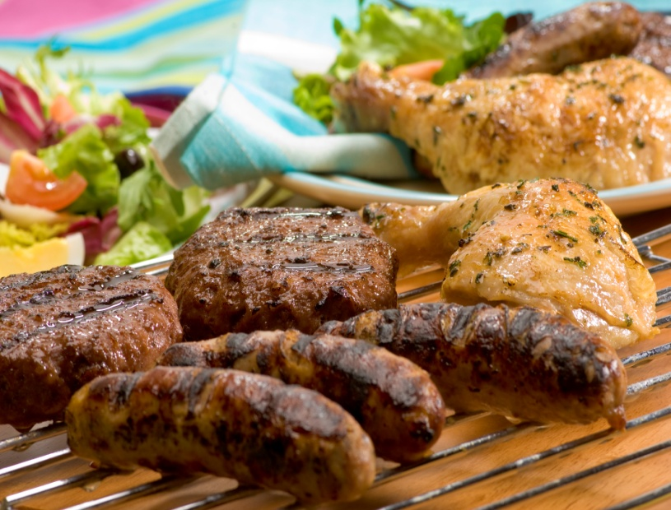
Featuring… The first phase of over fifty new products launched since February!
They include Arthur Pipkins sausage mixes, an on trend flavoursome Lemon & Tarragon specially developed specifically for poultry sausages, a traditional, moreish and Gluten Free Olde English Sausage Mix as well as the new pungent Cracked Black Pepper Sausage Mix which has been developed using a robust blend of ingredients. Inspired by the demand for healthy comfort food and the familiar flavours of Kentucky is the Arthur Pipkins Southern Barbecue Chicken Burger Mix. Specially developed for poultry burgers, it has the perfect blend of ingredients to ensure that the burger stays firm and moist during cooking and delivers on taste. All Arthur Pipkins mixes are free from artificial colours and flavours.
An extensive range of quality Sausage Seasonings, Sausage & Burger Mixes, Glazes, Coatings, Functional Ingredients, Spice Blends, Kitchen Essentials, Liquid Oil Based Marinades and Stir Fry Sauces are available at competitive prices. FREE samples are also available.
www.ifing.co.uk
www.newlywedsfoods.co.uk
www.avo.de
For further details please contact David Brennand on 07748 983401, your IFI Sales Representative or send an email to sales@ifing.co.uk

